1. The speed of the DELL “Inspiron” computer processor is given as 1.86 GHz. Which of the following is a correct representation of this value in standard form and base unit?

A. 1.86 x 10⁶ s B. 1.86 x 10⁶ s⁻¹ C. 1.86 x 10⁹ s⁻¹ D. 1.86 x 10⁹ ms⁻¹

2. An aeroplane is traveling towards East at a speed 400 kmh⁻¹. A strong wind then blows, causing the plane to fly towards North at a speed 400 kmh⁻¹. What is the change in velocity of the plane?

A. 400 kmh⁻¹ South East
B. 566 kmh⁻¹ North West
C. 400 kmh⁻¹ North West
D. 800 kmh⁻¹ North East

3. Which of the followings has the same unit as energy?

A. force x velocity
B. Pressure x volume
C. force x extension square
D. stress x strain

4. A micrometer, without zero error, is used to measure the diameter of a cylinder as shown. What is the diameter of the cylinder?

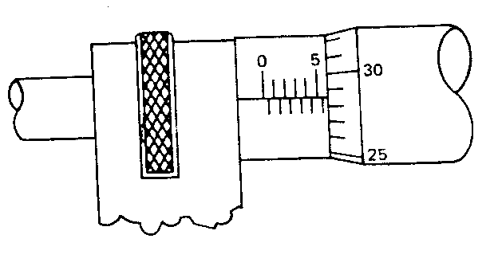

A. 5.29 mm B. 5.79 mm C. 0.29 mm D. 5.529 mm

5. A ticker-tape timer is used to investigate the motion of a toy car moving down an inclined plank. A section of the tape is shown below. The time interval between two dots is 0.02 s.

• • • • • •

10 cm

What is the average speed of the toy car during this part of the motion?

A. 25.0 cms⁻¹ B. 50.0 cms⁻¹ C. 83.3 cms⁻¹ D. 100 cms⁻¹

6. The density of a metal cube is determined using the displacement method. The volume of water displaced due to the metal cube is recorded as ( 8.0 + 0.2 ) cm. The mass, measured by a triple beam balance, is ( 30.0 + 0.1 ) g. Which is the correct representation of the density, in g/cm³ ?

A 3.75 + 0.01 B 3.8 + 0.1 C 3.8 + 0.3 D 4.0 + 0.1

7. A toy car undergoes a constant acceleration from rest to a speed of 20.0 ms⁻¹ over a distance of 20m. What is the speed of the toy car after a further distance 20.0 m if it continues with this acceleration?

A. 20.0 ms⁻¹ B. 28.3 ms⁻¹ C. 40.0 ms⁻¹ D. 80.0 ms⁻¹

8. A projectile is fired off from a level ground at angle of 45º the horizontal. Which of the statements is correct?

- The vertical speed is maximum at half the time of flight
- The maximum height is achieved at half the time of flight.
- The vertical acceleration is zero at half the time of flight
- The kinetic energy is zero at half the time of flight

9. An object of mass 5.0 kg falls from rest through air until it reaches terminal velocity. The air resistance varies with square of the speed of the object. Which graph best represents how the air resistance varies with time until it reaches terminal velocity?

F/N F/N F/N F/N

50 50
5 5

A B C D

10. Which of the following is a correct example of Newton’s 3rd Law of forces?

- Normal reaction force by the table on a book and weight of book
- Upthrust exerted by water on submarine and weight of submarine
- Engine thrust on the car moving at constant speed and friction by road
- Force on water gushing out of a garden hose and force to recoil the garden hose

11. The diagram shows a situation just after a head-on collision. The ball of mass 20 kg is traveling at 10 ms⁻¹ and the ball of mass 10 kg is traveling at 15 ms⁻¹ in the opposite direction. There is no net external force acting on the system.

10 ms⁻¹ 20 kg 10 kg 15 ms⁻¹

What is the magnitude of the total momentum before the collision?

A. 50 Ns B. 150 Ns C. 200 Ns D. 350 Ns

12. A charged magnetic sphere resting on a table has a weight W. What is the physical reason for this weight?

A. Gravitational force between the Earth and the object
B. Electrical force between the Earth and the charged sphere
C. Magnetic force exerted by the Earth’s magnetic field on the magnet
D. Normal reaction by the table acting against the sphere

13 A gas in a frictionless cylinder expands and pushes a piston outward. Which of the following describes the energy changes correctly?

A | g.p.e. of gas decreases | K.E. of piston increases
B | K.E. of gas decreases | K.E. of piston increases
C | Internal Energy of gas decreases | K.E. of piston increases
D | Internal Energy of gas increases | K.E. of piston increases

14. A hydropower station generates 100MW of electrical energy. If the efficiency of the power station is 80%, what is the power input to the power station?

A. 20 MW B. 80 MW C. 125 MW D. 225 MW

15. A force of 20N at an angle of 60º to the horizontal acts on an object resting on a rough horizontal surface. The gain in kinetic energy of the object after a distance of 10 m is 50 J. Calculate the frictional force acting against the object.

A. 5 N B. 20N C. 25 N D. 30 N

16 A ball is tied to a string and the other end of the string is attached to the ceiling of a bus. At one instant, the ball and string are in this position.

ceiling

θ

Which of the statements is incorrect?

- The vertical component of the tension is equal to the weight of the ball
- The ball is accelerating to the right
- The ball is in equilibrium
- The weight of the ball is acting vertically down.

17. A nut is held tightly by a bolt. To loosen it, an anticlockwise moment of 200 Nm is required. Determine the correct direction and magnitude of the force applied at point A to just loosen it.

nut

10 cm

handle

A

- 200 N to the right
- 200 N to the left
- 2000 N to the right
- 2000 N to the left

18. Solid has a fixed shape while liquid does not. Which of the following best explains this difference?

- Particles in solid can vibrate but particles in liquid has some translational motion
- The spacing between particles in liquid is greater than that in solid
- The particles in solid are fixed in a lattice while the particles in liquid can exchange position
- The particles in solid has a stronger bonds than those in liquid

19. Which of the following concerning the pressure at a point below a liquid surface in a container is correct?

A. It is greater on the moon’s surface than on the Earth’s surface
B. It is greater if the volume of liquid is greater
C. It is greater if the density of the liquid is greater
D. It is greater if the point is nearer to the surface of the liquid.

20. Which of the following comparisons about the process of boiling and evaporation is incorrect.

A. Both processes involve a change of phase from liquid to gas
B. More heat energy is required for boiling than for evaporation
C. Both processes involve a loss in internal energy
D. Boiling occurs at a particular temperature but evaporation occurs at all temperature

- A wire is stretched by a force F which causes an extension l. The energy stored in the wire is Fl only if

  - the extension of the wire is proportional to the force applied.
  - the weight of the wire is negligible.
  - the wire is not stretched beyond its elastic limit.
  - The acceleration of free fall is constant.

- The force F required to extend a sample of rubber by a length x was found to vary as shown in the diagram.

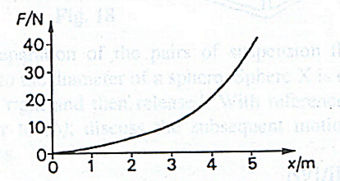

The energy stored in the rubber for an extension of 5 m is

  - more than 200 J
  - less than 100 J
  - between 100 J and 200 J
  - 100 J

- A spring obeying Hooke’s law has an unstretched length of 50 mm and a spring constant of 400 Nm⁻¹.
What is the tension in the spring when its overall length is 70 mm?

A. 8.0 N B. 28 N C. 160 N D. 400 N

- Visible light has wavelengths between 400 nm and 700 nm, and its speed in a vacuum is 3.0 x 10⁸ ms⁻¹. What is the maximum frequency of visible light?

A. 1.2 x 10¹¹ Hz B. 4.3 x 10¹¹ Hz C. 4.3 x 10¹⁴ Hz D. 7.5 x 10¹⁴ Hz

- If a wave can be polarised, it must be

- an electromagnetic wave
- a longitudinal wave
- a transverse wave
- a stationary wave

- In a Young’s double slit experiment, a small detector measures an intensity of illumination of I units at the centre of the fringe pattern. If one of the two (identical) slits is now covered, the measured intensity will be

A. 2I B. 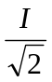 C. 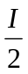 D. 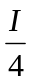

- Two wave generators S₁ and S₂ produce water waves of wavelength 2 m. They are placed 4 m apart in a water tank and a detector P is placed on the water surface 3 m from S₁ as shown in the diagram.

4 m
S₁
S₂
P

3 m

When operated alone, each generator produces a wave at P which has an amplitude A.
When the generators are operating together and in phase, what is the resultant amplitude at P?

A. 0 B. A C. 2A D. 4A

- A stationary wave is set up on a stretched string XY as shown in the diagram.

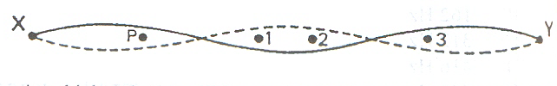
At which point(s) will the oscillation be in phase with that at P?

A. 3 only
- 2 and 3 only
- 1 and 2 only
- 1, 2 and 3

- An oil droplet has a charge –q and is situated between two parallel horizontal metal plates as shown in the diagram.
+V
-q
d
-V

The separation of the plates is d. The droplet is observed to be stationary when the upper plate is at potential +V and the lower at potential –V.
For this to occur, the weight of the droplet is equal in magnitude to

A. 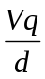 B. 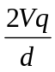 C. 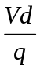 D. 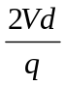

- A sample of resistive material is prepared in the form of a thin square slab of side x.
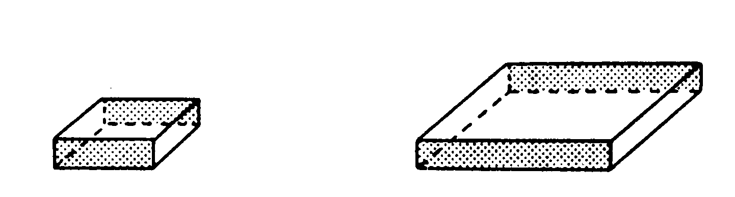
x
x

For a given thickness, the resistance between opposite edge faces of the sample (shown shaded) is

- proportional to x²
- proportional to x
- independent of x
- inversely proportional to x
- In the circuit shown below, the resistance of the tungsten filament lamp L increases with temperature. The current can be varied by means of a rheostat.

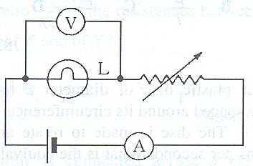

Which one of the following graphs best shows how the ammeter reading I varies with the voltmeter reading V?

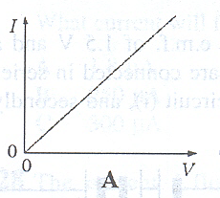 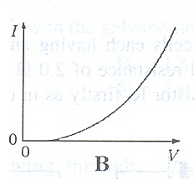`

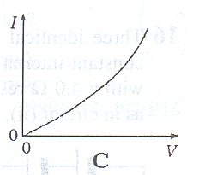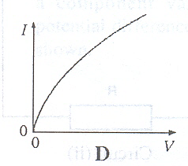

- Two wires P and Q, each of the same length and the same material, are connected in parallel to a battery. The diameter of P is half that of Q.
What fraction of the total current passes through P?

A. 0.20 B. 0.25 C. 0.33 D. 0.50

- The diagram shows the relation between the direct current I in a certain conductor and the potential difference V across it. When V < 1.8 V, the current is negligible.

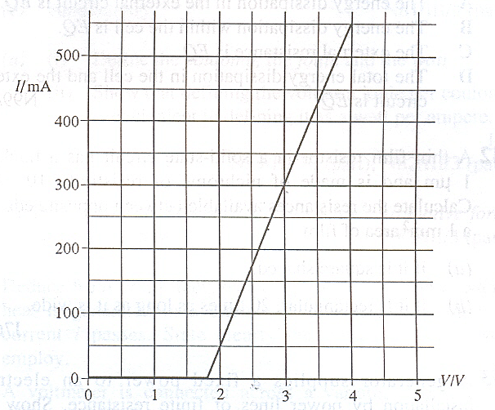

Which statement about the conductor is correct?

  - It does not obey Ohm’s law but when V > 1.8 V, its resistance is 4 Ω.
  - It does not obey Ohm’s law but when V = 3 V, its resistance is 10 Ω.
  - It obeys Ohm’s law when V > 1.8 V and when V = 3 V, its resistance is 10 Ω.
  - It obeys Ohm’s law when V > 1.8 V but its resistance is not constant.

- A resistor and three similar cells, each of e.m.f. 1.5 V and internal resistance 6 Ω, are connected as shown.

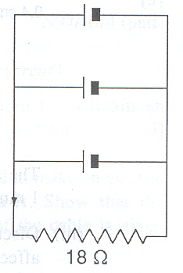

I
The current I through the resistor is

A. 0.075 A B. 0.083 A C. 0.24 A D. 0.36 A
- The resistors P, Q and R in the circuit have equal resistance.
P
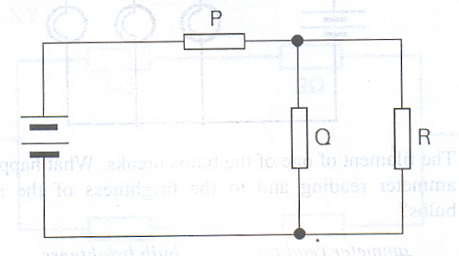
R
Q

The battery, of negligible internal resistance, supplies a total power of 12 W.
What is the power dissipated by heating in resistor R?

A. 2 W B. 3 W C. 4 W D. 6 W

- In the circuit shown, each of the resistors X and Y has resistance 6 Ω. The cell C has e.m.f. 12 V and internal resistance 3 Ω.

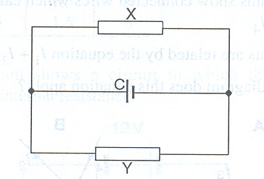

What is the current in Y?

A. 0.5 A B. 1.0 A C. 2.0 A D. 4.0 A

- In the circuit shown, there is a current of 3A in the 2 Ω resistor.

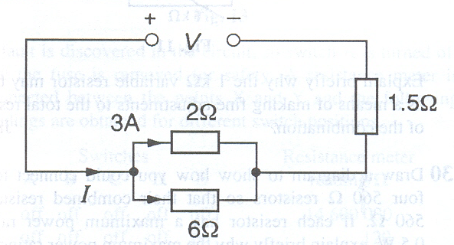

What are the values of the current I delivered by, and the voltage V across the power supply?

 | I/A | V/V
A | 3 | 10.5
B | 4 | 9
C | 4 | 12
D | 12 | 18

- The number of nucleons in the nucleus of the atom 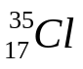 is

A. 17 B. 18 C. 35 D. 52

- The decay of 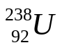 to 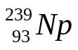 by β – emission is not possible because

  - β – decay only occurs in isotopes of low mass
  - is not a stable isotope
  - nucleon number cannot increase in a β - decay process
  - proton number cannot increase in a β - decay process

- When it disintegrates, a certain radioactive nuclide P emits γ – radiation and a single α – particle, forming a daughter product Q. Which one of the following statements is true?

  - P and Q are isotopes of the same element.
  - The nucleon number of P is one more than that of Q.
  - The nucleon number of P is one less than that of Q.
  - P has more protons in its nucleus than Q.

